MINOR REPORT

ON

**STUDY AND IMPLEMENTATION OF GESTURE CONTROLLED WIRELESS ROBOT**

Submitted in the partial fulfilment of the requirement for the award of degree of

BACHELOR OF TECHNOLOGY

IN

ELECTRONICS AND COMMUNICATION ENGINEERING

**SUBMITTED BY:**

ESHANT SAGAR (2K14/EC/067)

HAMAAD ULLAH ZUBERI (2K14/EC/074)

PRASHANT KUMAR (2K14/EC/111)

PAWAN KUMAR (2K14/EC/112)

**UNDER THE GUIDANCE OF:**

Mr. DEVA NAND

(ASSITANT PROFFESOR)



DEPARTMENT OF ELECTRONICS AND COMMUNICATION ENGINEERING

DELHI TECHNOLOGICAL UNIVERSITY

BAWANA ROAD, DELHI – 110042

(MAY 2017)

DECLARATION

This is to certify that the Self-Study entitled “**Study and Implementation of Gesture Controlled Wireless Robot**” prepared by us submitted in the partial fulfilment of the requirement for the award of degree of Bachelor of Technology in Electronics and Communication Engineering. Further, it stated that it is a bonafide record of the work done by us under guidance of **Mr. Deva Nand**, Assistant Professor, ECE Department, DTU. To the best of my knowledge, this work has not been submitted earlier/anywhere for similar project.

ESHANT SAGAR (2K14/EC/067)

HAMAAD ULLAH ZUBERI (2K14/EC/074)

PRASHANT KUMAR (2K14/EC/111)

PAWAN KUMAR (2K14/EC/112)

Department of Electronics and Communication Engineering

Delhi Technological University

DEVA NAND

Assistant Professor

Department of Electronics and Communications Engineering

Delhi Technological University

ACKNOWLEDGMENT

We have taken efforts in this project. However, it would not have been possible without the kind support and help of many individuals. We would like to extend our sincere thanks to all of them.

We would like to thank our professor **Mr. Deva Nand** for giving us this opportunity to do this project.

We would like to express our gratitude towards him and also thankful to him for giving us this opportunity to compile this project.

Our thanks and appreciations also go to all our friends and seniors in developing the project and people who have willingly helped us out with their abilities.

ABSTRACT

We have designed and implemented a wireless robot controlled using hand gestures. It uses an accelerometer to detect the tilting position of the hand, and a microcontroller gets different analog values and generates command signals to control the robot.

CONTENT

1. INTRODUCTION
2. COMPONENTS
   1. ADXL335
   2. HT12E
   3. HT12D
   4. L293D
   5. IC 7805 (VOLTAGE REGULATOR IC)
   6. ATMEGA328P
   7. RF MODULE (TRANSMITTER AND RECEIVER)
3. DESIGN
4. IMPLEMENTATION
5. SOURCE CODE
6. REFERENCES

LIST OF FIGURES

Figure 1. Internal circuit of ADXL335 10

Figure 2. ADXL335 10

Figure 3. Pin Diagram of HT12E 11

Figure 4. Pin Diagram of HT12D 12

Figure 5. Pin Diagram of L293D 13

Figure 6. Pin Diagram of IC 7805 13

Figure 7. ATmega328p 14

Figure 8. Pin diagram of ATmega328p and it's Arduino equivalent 15

Figure 9. Pin diagrams of RF Modules 16

Figure 10. Block diagram 17

Figure 11. Transmitter Circuit 17

Figure 12. Receiver Circuit 18

Figure 13. Transmitter PCB Layout 18

Figure 14. Receiver PCB Layout 18

LIST OF TABLES

Table 1. IC 7805 pin functions 14

Table 2. ATmega328p characteristics 15

Table 3. Movement of Robot and Decoder Outputs 19

CHAPTER 1

INTRODUCTION

Gesture recognition is the ability of a device to identify and respond to the different gestures of an individual. Most gesture recognition technology can be 2D-based or 3D-based, working with the help of working on coordinates using accelerometer or camera-enabled device, which is placed on or in front of the individual.

Gesture recognition is a topic in computer science and language technology with the goal of interpreting human gestures via mathematical algorithms.

Gestures can originate from any bodily motion or state but commonly originate from the face or hand. Users can use simple gestures to control or interact with devices without physically touching them.

Many approaches have been made using cameras and computer vision algorithms to interpret sign language. However, the identification and recognition of posture, gait, proxemics, and human behaviours is also the subject of gesture recognition techniques. Gesture recognition can be seen as a way for computers to begin to understand human body language, thus building a richer bridge between machines and humans than primitive text user interfaces or even GUIs (graphical user interfaces), which still limit the majority of input to keyboard and mouse.

The major application areas of gesture recognition in the current scenario are:

DEFENCE SECTOR

One of the concern areas of today is the military. Military robots are used to take the risky job which is difficult to be handled manually by human. These robots take the job as the assistant of a soldier. If you searching for the information on robots used in military then you have reached at the best online resource. Today, many military organizations take the helps of military robots to take risky jobs. These robots used in military are usually employed with the integrated system, including video screens, sensors, gripper and cameras. The military robots also have different shapes according to the purposes of each robot. In other words, these robots have helped military organizations in many ways. Go ahead and check out our articles to find out more about military robots and how these robots are being used by military organizations.

HEALTHCARE SECTOR

Wheelchairs are used by the people who cannot walk due to physiological or physical illness, injury or any disability. Recent development promises a wide scope in developing smart wheelchairs. The present article presents a gesture based wheelchair which controls the wheelchair using hand movements. The system is divided into two main units: Mems Sensor and wheelchair control. The Mems sensor, which is connected to hand, is an 3-axis accelerometer with digital output (I2C) that provides hand gesture detection, converts it into the 6- bit digital values and gives it to the PIC controller. The wheelchair control unit is a wireless unit that is developed using another controller.

AUTOMOTIVE & MANUFACTURING SECTOR

The military helicopter market is for the purpose of this analysis subdivided into two areas- military helicopters at 500 units per year and helicopter for special application as defence helicopters. Special mission rotor craft are about 200 unit per annum. the major manufacturers are Boeing, Sikorsky, Lockheed martin in USA and Eurocopter and Aguastswestland in Europe. Most of the market includes INS (Inertial Navigation Systems), AHRS (Attitude Heading Reference System) systems use lower price IMUs ($15-$20K compared to $50-$55K for navigation), giving a smaller market opportunity. Accelerometers are gaining ground in many military and aerospace applications thanks to reductions in price and size, greater operating ranges, higher resonant frequencies, lower amplitude ranges, MEMS technology, and integral electronics, but several challenges remain.

GAMING SECTOR

A motion gaming system, sometimes called a motion-controlled gaming system, is one that allows players to interact with the system through body movements. Input is usually through a combination of spoken commands, natural real-world actions and gesture recognition.

CHAPTER 2 COMPONENTS

2.1 ADXL335

The ADXL335 is a small, thin, low power, complete 3-axis accelerometer with signal conditioned voltage outputs. The product measures acceleration with a minimum full-scale range of ±3 g. It can measure the static acceleration of gravity in tilt sensing applications, as well as dynamic acceleration resulting from motion, shock, or vibration.

Applications:

Cost sensitive, low power, motion- and tilt-sensing applications

Mobile devices

Gaming systems

Disk drive protection

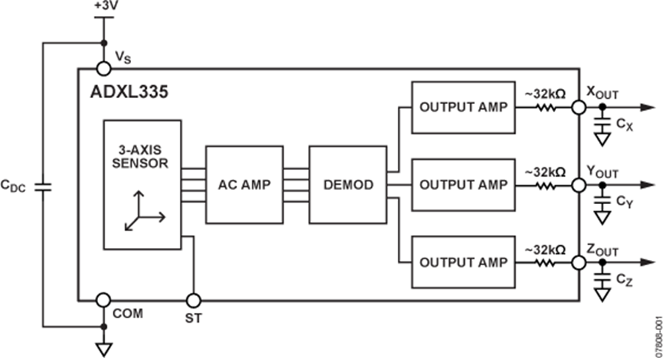Image stabilization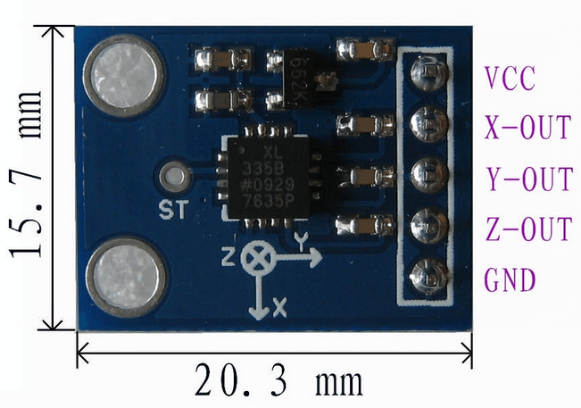

Figure 1. Internal circuit of ADXL335

Figure 2. ADXL335

2.2 HT12E

HT12E is an encoder integrated circuit of 212 series of encoders. They are paired with 212 series of decoders for use in remote control system applications. It is mainly used in interfacing RF and infrared circuits. The chosen pair of encoder/decoder should have same number of addresses and data format. HT12E converts the parallel inputs into serial output. It encodes the 12-bit parallel data into serial for transmission through an RF transmitter. These 12 bits are divided into 8 address bits and 4 data bits.

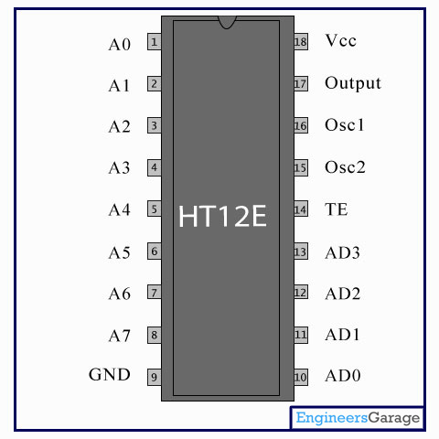

Figure 3. Pin Diagram of HT12E

HT12E has a transmission enable pin which is active low. When a trigger signal is received on TE pin, the programmed addresses/data are transmitted together with the header bits via an RF or an infrared transmission medium. HT12E begins a 4-word transmission cycle upon receipt of a transmission enable. This cycle is repeated as long as TE is kept low. As soon as TE returns to high, the encoder output completes its final cycle and then stops.

2.3 HT12D

HT12D is a decoder integrated circuit that belongs to 212 series of decoders. It is mainly provided to interface RF and infrared circuits. They are paired with 212 series of encoders. The chosen pair of encoder/decoder should have same number of addresses and data format.

In simple terms, HT12D converts the serial input into parallel outputs. It decodes the serial addresses and data received by, say, an RF receiver, into parallel data and sends them to output data pins. The serial input data is compared with the local addresses three times continuously. The input data code is decoded when no error or unmatched codes are found. A valid transmission in indicated by a high signal at VT pin.

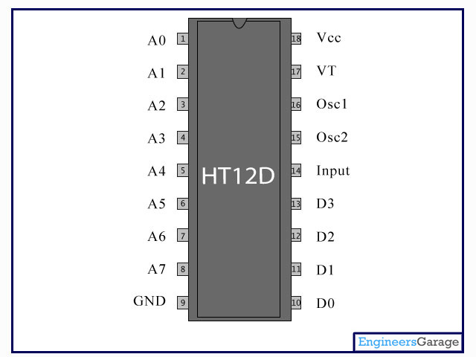

Figure 4. Pin Diagram of HT12D

HT12D is capable of decoding 12 bits, of which 8 are address bits and 4 are data bits. The data on 4 bit latch type output pins remain unchanged until new is received.

2.4 L293D

L293D is a dual H-bridge motor driver integrated circuit (IC). Motor drivers act as current amplifiers since they take a low-current control signal and provide a higher-current signal. This higher current signal is used to drive the motors.

L293D contains two inbuilt H-bridge driver circuits. In its common mode of operation, two DC motors can be driven simultaneously, both in forward and reverse direction. The motor operations of two motors can be controlled by input logic at pins 2 & 7 and 10 & 15. Input logic 00 or 11 will stop the corresponding motor. Logic 01 and 10 will rotate it in clockwise and anticlockwise directions, respectively.

Enable pins 1 and 9 (corresponding to the two motors) must be high for motors to start operating. When an enable input is high, the associated driver gets enabled. As a result, the outputs become active and work in phase with their inputs. Similarly, when the enable input is low, that driver is disabled, and their outputs are off and in the high-impedance state.

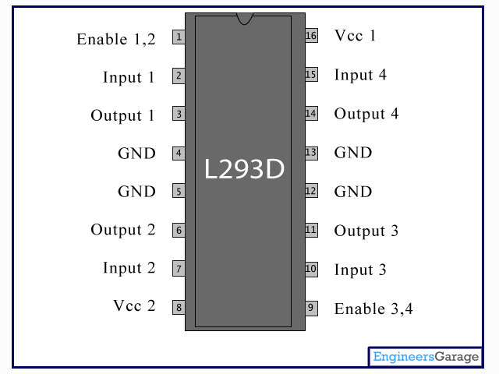

Figure 5. Pin Diagram of L293D

2.5 IC 7805 (VOLTAGE REGULATOR IC)

7805 is a voltage regulator integrated circuit. It is a member of 78xx series of fixed linear voltage regulator ICs. The voltage source in a circuit may have fluctuations and would not give the fixed voltage output.

The voltage regulator IC maintains the output voltage at a constant value. The xx in 78xx indicates the fixed output voltage it is designed to provide. 7805 provides +5V regulated power supply. Capacitors of suitable values can be connected at input and output pins depending upon the respective voltage levels.

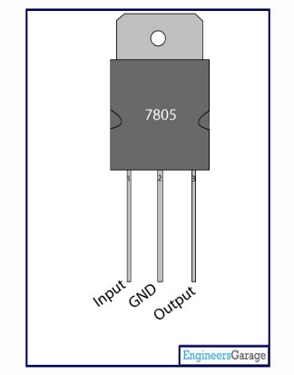

Figure 6. Pin Diagram of IC 7805

|  |  |  |
| --- | --- | --- |
| **Pin No** | **Function** | **Name** |
| 1 | Input voltage (5V-18V) | Input |
| 2 | Ground (0V) | Ground |
| 3 | Regulated output; 5V (4.8V-5.2V) | Output |

Table 1. IC 7805 pin functions

2.6 ATMEGA328P

ATmega328p is a single-chip microcontroller from Atmel and belongs to the mega AVR series. The Atmel 8-bit AVR RISC based microcontroller combines 32kB ISP flash memory with read-while-write capabilities, 1kB EEPROM, 2kB SRAM, 23 general-purpose I/O lines, 32 general-purpose working registers, three flexible timers/counters with compare modes, internal and external interrupts, serial programmable USART, a byte-oriented 2-wire serial interface, SPI serial port, 10-bit A/D converter, programmable watch-dog timer with an internal oscillator and five software-selectable power-saving modes.

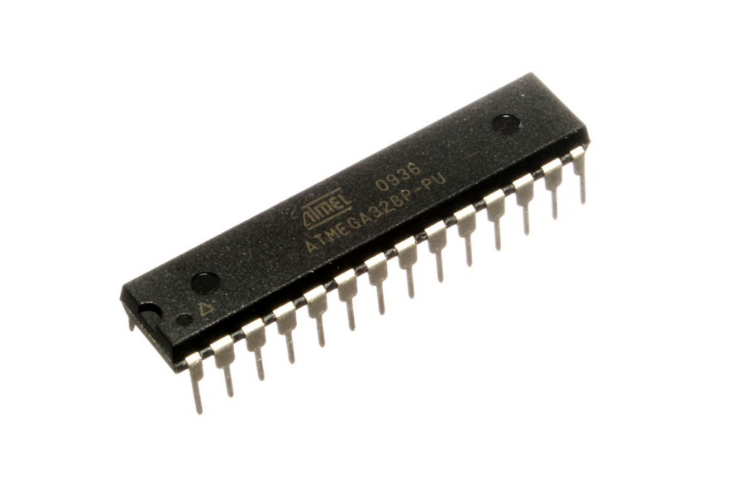

Figure 7. ATmega328p

|  |  |
| --- | --- |
| **Microcontroller** | ATmega328 |
| **Operating Voltage** | 5V |
| **Input Voltage (recommended)** | 7-12V |
| **Input Voltage (limit)** | 6-20V |
| **Digital I/O Pins** | 14 (of which 6 provide PWM output) |
| **PWM Digital I/O Pins** | 6 |
| **Analog Input Pins** | 6 |
| **DC Current per I/O Pin** | 20 mA |
| **DC Current for 3.3V Pin** | 50 mA |
| **Flash Memory** | 32 KB of which 0.5 KB used by bootloader |
| **SRAM** | 2 KB |
| **EEPROM** | 1 KB |
| **Clock Speed** | 16 MHz |

Table 2. ATmega328p characteristics

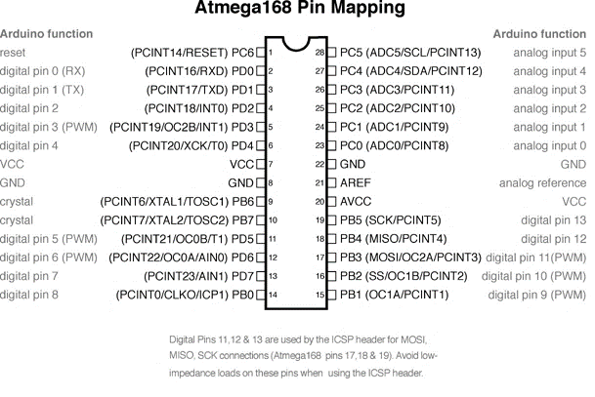

Figure 8. Pin diagram of ATmega328p and it's Arduino equivalent

2.7 RF MODULE (TRANSMITTER AND RECEIVER)

The RF module, as the name suggests, operates at Radio Frequency. The corresponding frequency range varies between 30 kHz & 300 GHz. In this RF system, the digital data is represented as variations in the amplitude of carrier wave. This kind of modulation is known as Amplitude Shift Keying (ASK).

Transmission through RF is better than IR (infrared) because of many reasons. Firstly, signals through RF can travel through larger distances making it suitable for long range applications. Also, while IR mostly operates in line-of-sight mode, RF signals can travel even when there is an obstruction between transmitter & receiver. Next, RF transmission is more strong and reliable than IR transmission. RF communication uses a specific frequency unlike IR signals which are affected by other IR emitting sources.

This RF module comprises of an RF Transmitter and an RF Receiver. The transmitter/receiver (Tx/Rx) pair operates at a frequency of 434 MHz. An RF transmitter receives serial data and transmits it wirelessly through RF through its antenna connected at pin4. The transmission occurs at the rate of 1Kbps - 10Kbps.The transmitted data is received by an RF receiver operating at the same frequency as that of the transmitter.

The RF module is often used along with a pair of encoder/decoder.

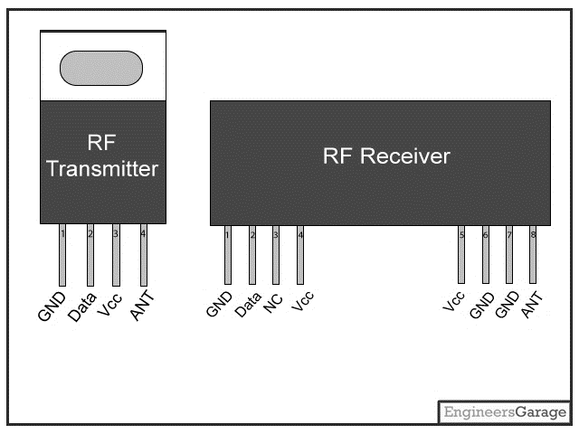

Figure 9. Pin diagrams of RF Modules

CHAPTER 3

DESIGN

An accelerometer is used to detect the tilting position of your hand, and the ATmega328 microcontroller gets different analog values and generates command signals to control the robot.

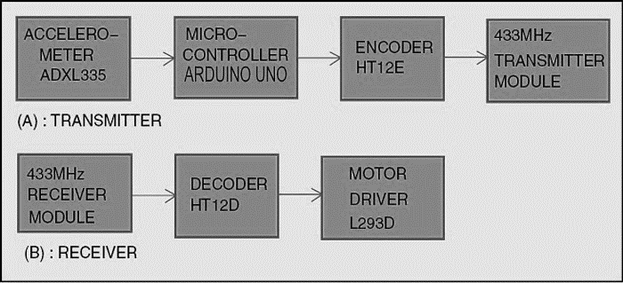

Figure 10. Block diagram

The transmitter circuit is as follows:

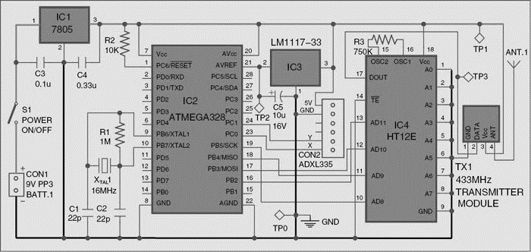

Figure 11. Transmitter Circuit

The receiver circuit is as follows:

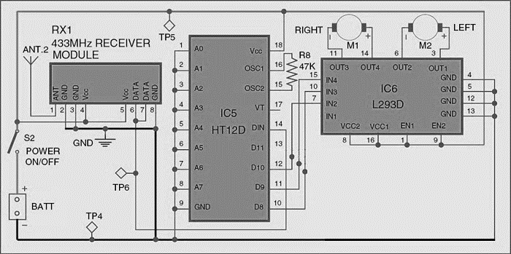

Figure 12. Receiver Circuit

The component layouts on the PCB are given below:

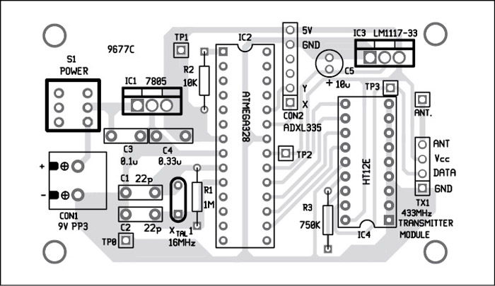

Figure 13. Transmitter PCB Layout

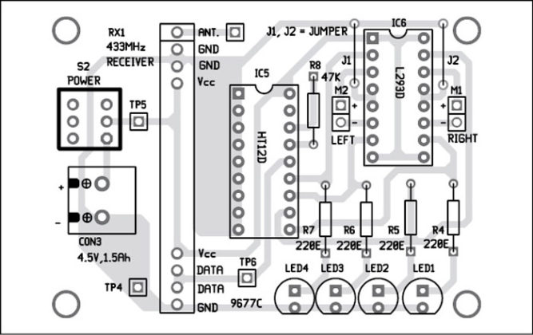

Figure 14. Receiver PCB Layout

|  |  |  |  |  |
| --- | --- | --- | --- | --- |
| Robot (accelerometer) | Input 1 (D11) | Input 2 (D10) | Input 3 (D09) | Input 4 (D08) |
| Forward (+X) | 0 | 1 | 0 | 1 |
| Backward (-X) | 1 | 0 | 1 | 0 |
| Right (Y) | 1 | 0 | 0 | 1 |
| Left (Y) | 0 | 1 | 1 | 0 |

Table 3. Movement of Robot and Decoder Outputs

CHAPTER 4

IMPLEMENTATION

The designed Temperature Indicator was implement on a printed circuit board and all the components were soldered according the circuit.

A printed circuit board (PCB) mechanically supports and electrically connects electronic components using conductive tracks, pads and other features etched from copper sheets laminated onto a non-conductive substrate. Components (e.g. capacitors, resistors or active devices) are generally soldered on the PCB.

The layout of the transmitter and receiver was etched on to the copper board to make a PCB.

CHAPTER 5

SOURCE CODE

const int ap1 = A0;

const int ap2 = A1;

int sv1 = 0;

int ov1 = 0;

int sv2 = 0;

int ov2= 0;

void setup()

{

// initialize serial communications at 9600 bps:

Serial.begin(9600);

pinMode(13,OUTPUT);

pinMode(12,OUTPUT);

pinMode(11,OUTPUT);

pinMode(10,OUTPUT);

}

void loop()

{

analogReference(EXTERNAL); //connect 3.3v to AREF

// read the analog in value:

sv1 = analogRead(ap1);

ov1 = map(sv1, 0, 1023, 0, 255);

delay(2);

sv2 = analogRead(ap2);

ov2 = map(sv2, 0, 1023, 0, 255);

delay(2);

Serial.print("Xsensor1 = " );

Serial.print(sv1);

Serial.print("\t output1 = ");

Serial.println(ov1);

Serial.print("Ysensor2 = " );

Serial.print(sv2);

Serial.print("\t output2 = ");

Serial.println(ov2);

if(analogRead(ap1)<514 &&analogRead (ap2)<463) // for backward movement

{

digitalWrite(13,HIGH);

digitalWrite(12,LOW);

digitalWrite(11,HIGH);

digitalWrite(10,LOW);

}

else

{

if(analogRead(ap1)<486 &&analogRead (ap2)>508) // for left turn

{

digitalWrite(13,LOW);

digitalWrite(12,HIGH);

digitalWrite(11,HIGH);

digitalWrite(10,LOW);

}

else

{

if(analogRead(ap1)>512 &&analogRead (ap2)>560) // for forward

{

digitalWrite(13,LOW);

digitalWrite(12,HIGH);

digitalWrite(11,LOW);

digitalWrite(10,HIGH);

}

else

{

if(analogRead(ap1)>550 &&analogRead (ap2)>512)//for right turn

{

digitalWrite(13,HIGH);

digitalWrite(12,LOW);

digitalWrite(11,LOW);

digitalWrite(10,HIGH);

}

else

{

digitalWrite(13,HIGH);

digitalWrite(12,HIGH);

digitalWrite(11,HIGH);

digitalWrite(10,HIGH);

}

}

}

}

}

REFERENCES

1. HAND GESTURE CONTROLLED ROBOT by Abhimanyu Rathore, Electronics 4 You, March 2015.
2. ARDUINO UNO [https://www.arduino.cc/en/Main/ArduinoBoardUno]
3. L293D Datasheet [http://www.engineersgarage.com/electronic-components/lm35-sensor-datasheet]
4. ADXL335 Datasheet [http://www.analog.com/en/products/mems/accelerometers/adxl335.html]
5. HT12E Datasheet [http://www.engineersgarage.com/electronic-components/lm35-sensor-datasheet]
6. HT12D Datasheet [http://www.engineersgarage.com/electronic-components/lm35-sensor-datasheet]
7. 7805 VOLTAGE REGULATOR Datasheet [http://www.engineersgarage.com/electronic-components/lm35-sensor-datasheet]